

WORK REPORT ON STUDENT INDUSTRIAL

WORK EXPERIENCE SCHEME (SIWES)

UNDERTAKEN AT

THE INTERNATIONAL INSTITUTE OF TROPICAL AGRICULTURE, IDI-OSE,

OFF OYO EXPRESSWAY, IBADAN.

BY

OLASUPO TOMIWA EMMANUEL

MATRIC NO: 222370

THE DEPARTMENT OF BOTANY, FACULTY OF SCIENCE

UNIVERSITY OF IBADAN

SUBMITTED TO INDUSTRIAL TRAINING COORDINATING CENTRE (ITCC),

UNIVERSITY OF IBADAN.

JULY, 2024.

Department Of Botany,

Faculty of Science,

University Of Ibadan.

19th JULY, 2024.

The Director,

Industrial Training Coordinating Centre (ITCC),

University Of Ibadan.

Dear Sir,

SUBMISSION OF INDUSTRIAL TRAINING WORK REPORT

I, OLASUPO TOMIWA EMMANUEL, a 300-level student in the Department of Botany with the matriculation number 222370 hereby present a work report which contains the expertise I acquired during my industrial training at the Nematology Unit, International Institute of Tropical Agriculture.

Thank you for the privilege of being part of this program.

Yours faithfully,

OLASUPO TOMIWA.

**ACKNOWLEDGMENT**

I appreciate God almighty for the gift of life, protection and strength to successfully go through my industrial training. I want to specially appreciate my family members for their support and encouragement all throughout the program. I also appreciate the Industrial Training Coordinating Centre for this initiative which has opened my eyes to the practical aspects of my course of study and also the work environment.

I also appreciate everyone that contributed to the success of my industrial training one way of the other: My lecturer – Dr. O O Popoola for securing a spot for me at the institute, my unit supervisor – Dr Omowunmi Adewuyi for the guidance and teachings given to me and my colleagues to help shape our skills and carry out assigned tasks. However, my training wouldn’t have been possible without the help of other skilled staff and casual staff with whose experience I was able to learn more and maneuver difficult situations.

Lastly, I would like to appreciate my fellow IT students from University of Ibadan and the friends I made from other schools for their cooperation and support.

**TABLE OF CONTENT**

Title page

Letter of submission of Industrial Training Report i

Acknowledgement ii

Table of content iii

Abstract iv

Introduction 1

Chapter 1: Biology of Plant Parasitic Nematodes…………………………………3

Chapter 2: Nematology / Striga Unit …………………………………………….11

Chapter 3: Nematodes assessment and management …………………………....15

Chapter 4: Identification of Nematodes ……………………………………….…21

Conclusion : ……………………………………………………………………...26

References…………………………………………………………………………27

**ABSTRACT**

This report is based on my experience working at the International Institute of Tropical Agriculture (IITA), Ibadan, in the Nematology/Striga Unit, under the Students Industrial Work Experience Scheme.

It spotlights nematodes, a broad class of worm-like creatures that can be found both as free-living animals and as parasites in nearly every kind of habitat. Because they are notoriously hard to manage, nematodes seriously jeopardize the yields of sustainable agriculture. In comparison to temperate conditions, these difficulties are more severe in tropical regions, which makes it more difficult to identify and understand individual nematode species and groups.

During my time at the Nematology Unit, I gained hands-on experience in culturing nematodes, observing their effects on plants, extracting nematodes from plant and soil samples, preserving and identifying different nematode species, and implementing various control methods. Chapter one to four of this report detail everything I learned and carried out during the Students Industrial Work Experience Scheme.

**INTRODUCTION**

SIWES: The Students’ Industrial Work Experience Scheme is a skills training program designed to prepare students of universities and other tertiary institutions for the work environment they are going to meet after graduation. The main objective of the program is to bridge theory with practice by making it possible for students to get themselves exposed to the practical aspects of their courses of study, jobs in their various field and the work environment.

IITA: The International Institute of Tropical Agriculture (IITA) is a non-profit institution that generates agricultural innovations to meet Africa’s most pressing challenge of hunger, malnutrition and poverty. Since 1967, IITA has worked with various international and national partners, to improve livelihoods, enhance food and nutrition security, increase employment and preserve natural resource integrity.

IITA is guide by an ambitious strategy to lift 11.5 million people out of poverty and revitalize millions of hectares of farm land. As one of the 15 research centers in the Consultative Group on International Agricultural Research (CGIAR) which is a global partnership for a food secure future, IITA is engaged in several research programs and has delivered more than 70% of the CGIAR’s impact in sub-saharan Africa and is committed to science-driven improvement of agriculture and other food value chains.



*Fig 1.0:* IITA main entrance.

IITA as a research-for-development (R4D) organization has implemented programs that are focused on four areas: Biotechnology and genetic improvement, Natural Resource management, Social science and Agribusiness, Plant production and plant health. There are several units based on the major research crops undertaken by the the institute viz: Cassava Breeding Unit, Yam Breeding Unit, Banana/Plantain Breeding Unit, Cowpea Unit, Maize Breeding Unit, Soybean Breeding Unit; others include those based on crop protection and improvement: Pathology Unit, Virology Unit, Entomology Unit, Nematology/Striga Unit, Soil Microbiology Unit etc. Others include Agronomy Unit, Research Farm Unit, Crop Transformation/Utilization Unit, Genetic Resources Center, Communication/Publishing Unit, Bio-sciences Unit, Analytical Services Unit etc.

During the course of my SIWES program, The Nematology / Striga unit which falls under the forth areas in which IITA focuses on allowed me to have a practical experience on nematodes, its culturing, effects and various methods involved in extracting it from infested plants.

Having my Industrial Training at IITA was an awesome experience as I got the opportunity of learning new things and meeting new people from all over the world.

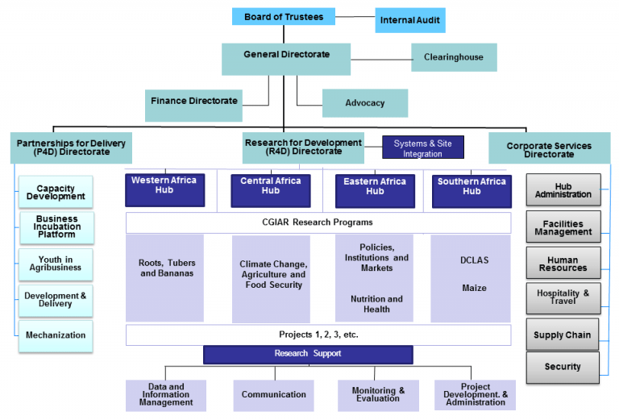*Fig 1.1:* IITA Organogram

**CHAPTER ONE**

BIOLOGY OF PLANT PARASITIC NEMATODES

Nematodes are a diverse group of worm-like animals. They are found in virtually every environment, both as parasites and as free-living organisms. They are generally minute, but some species can reach several meters in length.

Because nematodes are difficult or impossible to see in the field, and their symptoms are often non-specific, the damage they inflict is often attributed to other, more visible causes. Farmers and researchers alike often underestimate their effects. A general assessment is that plant parasitic nematodes reduce agricultural production by approximately 11% globally (Agrios, 2005), reducing production by millions of tonnes every year.

The amount of damage nematodes cause depends on a wide range of factors, such as their population density, the virulence of the species or strain, and the resistance (ability of the plant to reduce the population of the nematode) or tolerance (ability of the plant to yield despite nematode attack) of the host plant. Other factors also contribute to a lesser extent, including climate, water availability, soil conditions, soil fertility, and the presence of other pests and diseases. However, although we have some knowledge on the nematode–crop relationship and influencing factors, much remains to be learned. Damage thresholds for nematodes on various crops in various parts of the world, for example, are often unknown, and the threat nematodes pose often requires an educated guess.

**Appearance and structure**

Plant parasitic nematodes are mostly thread-like worms ranging from 0.25 mm to >1.0 mm long, with some up to 4.0 mm. Although most taper toward the head and tail, they come in a variety of shapes and sizes . Females of some species lose their worm-like shape as they mature, becoming enlarged and pear-, lemon- or kidney-shaped or spherical as adults. Like all animals, nematodes have circulatory, respiratory and digestive systems . Plant parasitic nematodes differ from nematodes that feed on bacteria and fungi in that they have a specialized feeding structure, the spear or stylet . This is used to inject enzymes into plant cells and tissues and then to extract the contents, in a similar way that aphids feed on plants.

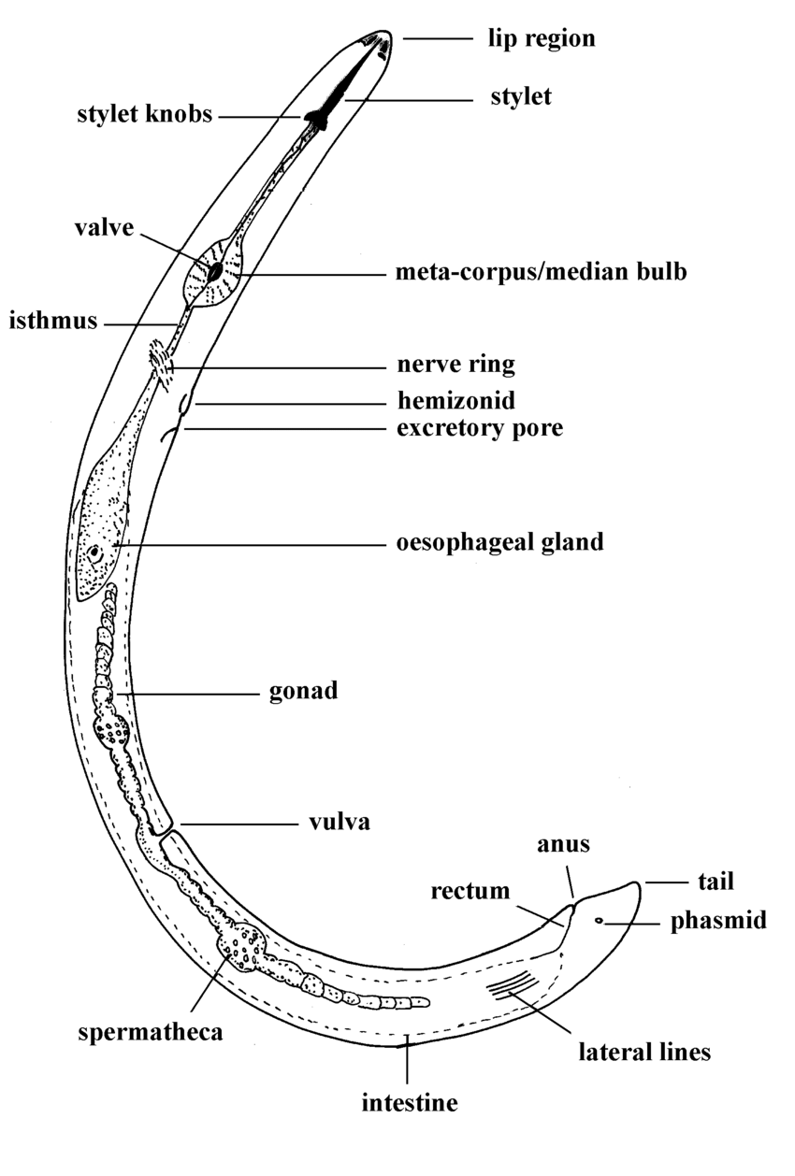

*Fig 1.2:* Picture of a nematode

**Life cycle**

The nematode life cycle is typically divided into six stages: the egg, four juvenile stages and the adult (Fig. 4). The duration of any of these stages and of the complete life cycle differs for different species, and also depending on factors such as temperature, moisture and plant host. Under favorable conditions in the tropics many species have relatively short life cycles, with several generations possible per season. This can lead to rapid population build up from just one (if self-fertilizing) or two nematodes.

Nematodes can survive unfavorable conditions, such as a dry season or a cold winter. Different species survive best at different life stages, for example *Heterodera* species survive best as eggs encapsulated within cysts, *Ditylenchus* species as fourth stage juveniles, and *Anguina* species as second stage juveniles.

Here is an overview of some species of plant-parasitic nematodes:

1. Root-Knot Nematodes (*Meloidogyne spp.*)

These nematodes are among the most destructive plant parasites, affecting a wide range of crops.

* ***Meloidogyne incognita*:** Affects many vegetables, fruits, and ornamentals.
* ***Meloidogyne javanica*:** Common in warmer climates and also affects a wide variety of plants.
* ***Meloidogyne arenaria*:** Often found in sandy soils and affects peanuts, tomatoes, and other crops.
* ***Meloidogyne hapla*:** Known as the northern root-knot nematode, it affects crops in cooler regions.

2. Cyst Nematodes (*Heterodera and Globodera spp.*)

These nematodes form cysts on the roots, which contain eggs that can survive in soil for many years.

* ***Heterodera glycines*:** Known as the soybean cyst nematode, it is a major pest of soybean crops.
* ***Heterodera schachtii*:** Affects sugar beets and other crops.
* ***Globodera rostochiensis*:** Known as the golden nematode, it affects potatoes and other solanaceous crops.
* ***Globodera pallida*:** Another potato cyst nematode, it is closely related to G. rostochiensis.

3. Lesion Nematodes (Pratylenchus spp.)

These nematodes cause lesions on roots, leading to root rot and reduced plant vigor.

* ***Pratylenchus penetrans*:** Affects a wide range of crops, including fruit trees, vegetables, and ornamentals.
* ***Pratylenchus brachyurus*:** Common in tropical and subtropical regions, it affects many crops, including soybeans and corn.
* ***Pratylenchus thornei*:** A significant pest of wheat and other cereals.

4. Stubby-Root Nematodes (*Trichodorus and Paratrichodorus spp.*)

These nematodes cause stunted and stubby roots, impacting plant growth.

* ***Trichodorus obtusus*:** Affects a variety of crops, including vegetables and turfgrass.
* ***Paratrichodorus minor*:** Known to transmit plant viruses and affect crops like potatoes and tomatoes.

5. Dagger Nematodes (*Xiphinema spp.*)

These nematodes have long stylets and can transmit plant viruses.

* ***Xiphinema index*:** Known for transmitting grapevine fanleaf virus.
* ***Xiphinema americanum*:** Affects many crops and is known for transmitting several plant viruses.

6. Ring Nematodes (*Criconemoides and Mesocriconema spp.*)

These nematodes cause damage by feeding on roots, leading to stunted growth and reduced yields.

* ***Criconemoides xenoplax*:** Commonly affects peach trees and is associated with peach tree short life.
* ***Mesocriconema xenoplax*:** Affects a wide range of crops, including fruit trees and vegetables.

7. Spiral Nematodes (*Helicotylenchus spp.*)

These nematodes coil their bodies into a spiral shape and feed on root surfaces.

* ***Helicotylenchus dihystera*:** Affects many crops, including cereals, legumes, and vegetables.
* ***Helicotylenchus multicinctus*:** Known to affect banana and plantain crops.

8. Reniform Nematodes *(Rotylenchulus spp.*)

These semi-endoparasitic nematodes partially enter the roots, causing damage.

***Rotylenchulus reniformis*:** A major pest of cotton, soybeans, and pineapple.

9. Burrowing Nematodes (*Radopholus spp.*)

These nematodes burrow into roots, causing extensive damage.

***Radopholus similis:*** Known as the burrowing nematode, it is a significant pest of banana and citrus.

10. Stem and Bulb Nematodes (*Ditylenchus spp*.)

These nematodes attack above-ground plant parts, causing distortion and swelling.

* ***Ditylenchus dipsaci*:** Known as the stem and bulb nematode, it affects onions, garlic, and ornamental bulbs.
* ***Ditylenchus destructor*:** Affects potato tubers and other root crops.

11. Foliar Nematodes (*Aphelenchoides spp.*)

These nematodes infest leaves and stems, causing lesions and distortion.

* ***Aphelenchoides besseyi*:** Known as the rice white tip nematode, it affects rice and other crops.
* ***Aphelenchoides ritzemabosi*:** Causes chrysanthemum foliar nematode disease and affects a variety of ornamental plants. 

**Symptoms of plants affected with Nematodes**

Symptoms of nematode damage are found both above and below ground.

* Above-ground symptoms

Above-ground symptoms fall into two categories: those caused by aerial nematodes attacking foliage and those caused by root nematodes attacking plant roots.

Symptoms caused by aerial nematodes .These are often specific symptoms associated with the nematode pest and therefore may be diagnostic. They include:

• Gall formation, or abnormal swelling of seeds (e.g. *Anguina*) or leaves (e.g. *Cynipanguina*)

• Leaf stripe, bleaching and discoloration of leaves (especially in temperate climates) (e.g. *Aphelenchoides*)

• Swollen, crinkled and disorganized tissue growth (e.g. *Ditylenchus*)

• Internal stem necrosis, signified with a red ring (*Bursaphelenchus cocophilus*) • Inflorescence necrosis

• Chlorosis/browning of leaves (needles in pines) and eventual tree death (*Bursaphelenchus xylophilus*).

* Symptoms caused by root nematodes

Root nematodes almost always cause varying degrees of abnormal above-ground growth, but these symptoms alone are generally not enough to diagnose a root nematode problem. Most symptoms reflect or can be mistaken for other problems, such as reduced water uptake or disturbed mineral absorption. They include:

• Chlorosis (yellowing) or other abnormal coloration of foliage

• Patchy, stunted growth

• Thin or sparse foliage

• Symptoms of water stress, such as wilting or leaf rolling.

**Below-ground symptoms**

These are due to root nematodes, and may be specific enough to allow diagnosis of the root nematode problem. Uprooting of plants or excavation of roots is needed to observe symptoms. Symptoms include:

• Galling

• Shortened, stubby or abbreviated roots

• Root lesions

• Root or tuber necrosis, rotting or death

• Root or tuber cracking

• Cysts or ‘pearly’ root

• Deformed roots

• Altered root architecture.

Root galls Root galls are caused mostly by the root-knot nematodes (*Meloidogyne* spp.), although other nematodes such as *Nacobbus aberrans* may also cause galling . Feeding by some nematodes, such as *Xiphinema spp*., may result in swellings or less defined galls, often at the root tips.

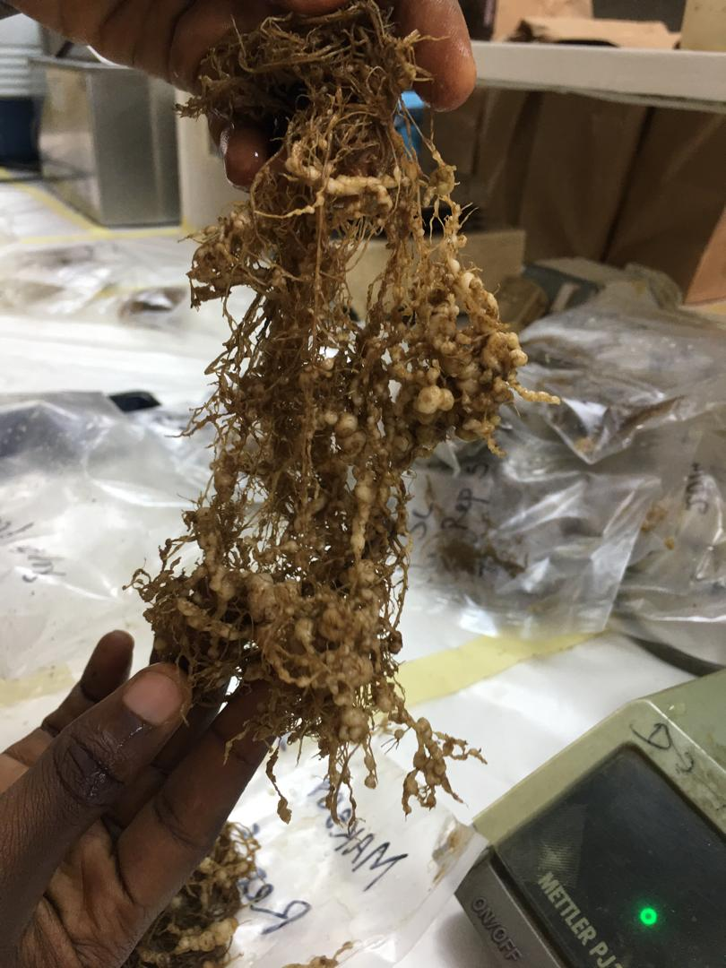

*Fig 1.3:* Image showing a heavily galled root

**CHAPTER TWO**

NEMATOLOGY / STRIGA UNIT

The IITA Nematology / Striga unit, led by Dr. Omowumi Adewuyi, is tasked with conducting research on nematode-infested plants with the goal of developing innovations to control the effects of nematodes on agricultural produce, which is a threat to long-term crop production. The fundamental aim of IITA is to ensure Sub-Saharan Africa's future stability and food security. As a result, the unit conducts research on staple food crops afflicted by nematodes, such as banana and plantain, cassava, cowpea, maize, soybean, and yam. The unit also carry out research on Striga which are parasitic weeds that affects cereal crops in many parts of Africa. However, during the course of my SIWES program, the unit worked mainly on nematodes.

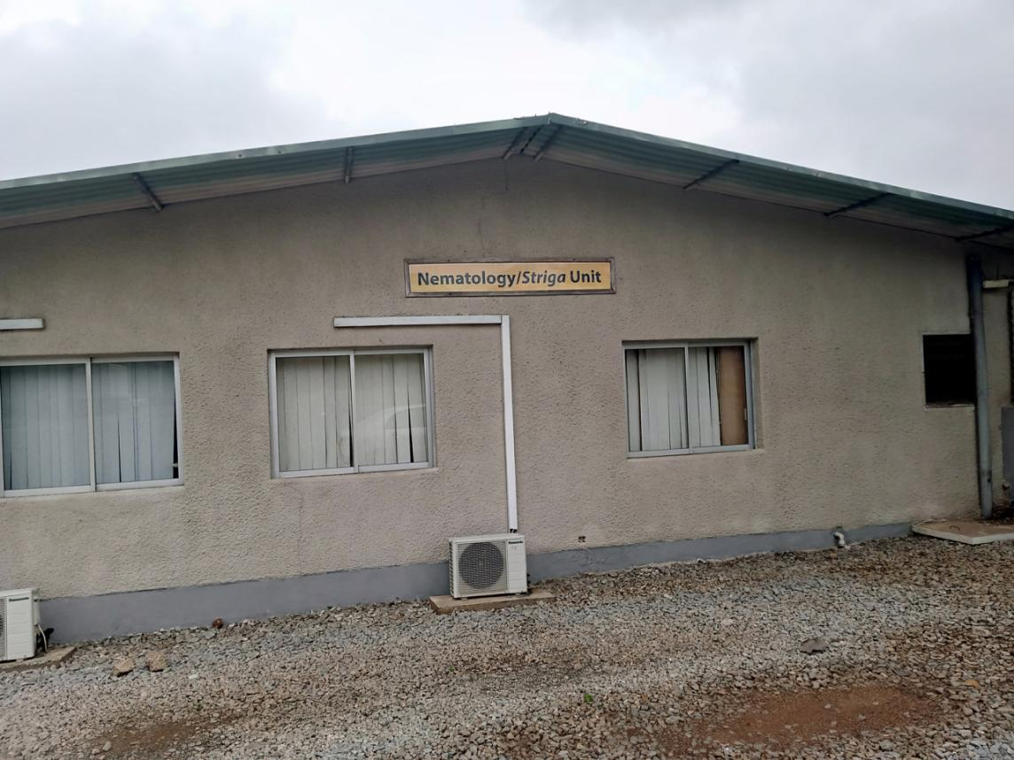

*Fig 2.0:*  Outer view of the unit

The unit conducts crop protection and improvement research, analyzes samples, sterilizes soil sample, evaluates data, and promotes healthy planting practices. They support research fellows (MSc, PhD) and provide professional nematode control instructions to other divisions within the institute, as well as farmers. The unit also provides services such as soil sterilization, nematode disease detection and assessment, as well as capacity building programs for NYSC, IT students, and student excursions.

The unit also offer soil sterilization service to other units who are in need of sterilized soil. Soil steam sterilizers are employed to sterilize soil using steam, applicable in open fields, greenhouses, or carts. This method effectively kills plant pests such as weeds, bacteria, fungi, and viruses through the application of hot steam, which denatures essential cellular proteins. The benefits of steaming include improved initial soil conditions, faster plant growth, and enhanced resistance to diseases and pests. The soil steam sterilizer machine operates using water, electricity, and diesel.

The unit has three sub division which are as follows:

* Screen House
* Laboratory
* Micro-plot

**Screen House**

These are enclosed buildings that shield the plants from unfavorable biotic elements mostly using net along the sides and nylon coverings. Here, experimental research is carried out which include culturing of nematodes by transplanting plants grown on nursery beds into pots with nematode-infested soil, measuring the plant's algorithm parameters, and collecting soil samples for study.

Various plants are used to culture nematodes in nematology unit such as Celosia, tomato, plantain, maize, rice and yam. Also, data are collected while the experiment is in progress and at the termination of the experiments. Some of the data being collected include growth parameters such as plant height, number of leaves, stem girth. It is significant to remember that when research is to be done on a particular plant, that plant is made available in various representative quantities, allowing us to have a broad understanding of the impact of nematodes on the plant.

During the course of the training, I was paired with a fellow IT student to be incharge of one the screen houses. Our activities in the screen house include :

* Watering of plants.
* Scraping of algae when necessary.
* Weeding
* Transplanting of seedlings.

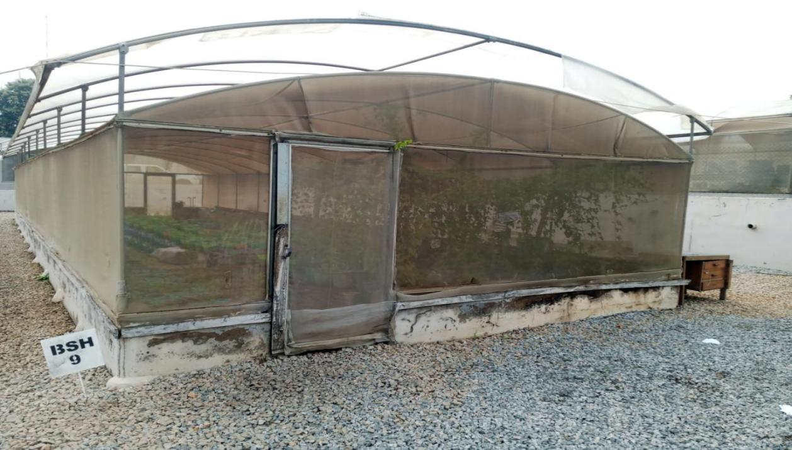

*Fig 2.1 :* Picture showing one of the screen house

**Laboratory**

This is where where scientific experiments, analysis, and research are carried out. Activities carried out in the laboratory include; extraction of nematodes from samples, counting of nematodes, microscopic identification of various nematodes. The table below show various equipment used in the Laboratory

|  |  |  |
| --- | --- | --- |
| **S/N** | **EQUIPMENT** | **USES** |
| 1 | Microscope | For observing nematodes |
| 2 | Sterilizer | To purify materials used in the lab e.g petri dish |
| 3 | Pipette | To obtain extract containing nematodes |
| 4 | Weighing scale | To weigh the yield obtained from the screen house |
| 5 | Desktop | To record data obtained from research carried out |
| 6 | Vortex | To mix samples when necessary |
| 7 | Blender | To reduce root samples into smaller sizes |
| 8 | Desiccator | To dry samples under atmospheric pressure |

*Table 2.0* showing different equipment in the laboratory and their functions

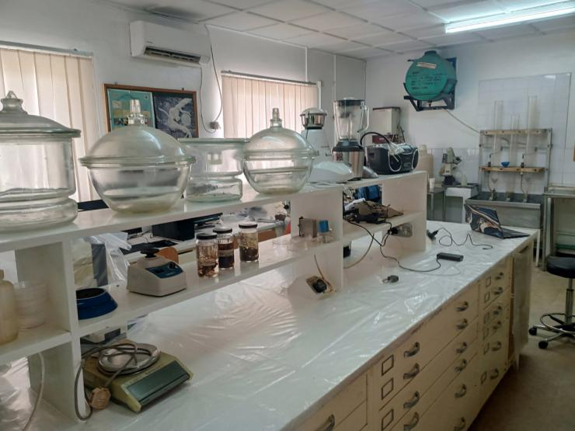

*Fig 2.2 :* Picture showing the Laboratory

**Micro-plot**

This is a farm field where experiments are carried out. As opposed to the screen houses where plants are planted into pots, here plants are planted directly into the soil for experimental and research purposes. These plots are typically small in size, ranging from a few square meters to a few dozen square meters, and are carefully managed to minimize external influences and variables, allowing researchers or trainees to observe and measure specific outcomes under controlled conditions.

During my industrial training, activities conducted on the micro plot primarily centered around planting of maize and application of NPK fertilizer using the side dressing method. This focused approach aimed to demonstrate practical aspects of agricultural management, emphasizing precision in fertilizer application as a critical factor in crop development.

**CHAPTER THREE**

NEMATODES ASSESMENT AND MANAGEMENT

**Damage analysis: scoring of nematodes symptoms on plant**

During my industrial training, I performed damage analysis by evaluating nematode symptoms on plants. This evaluation was conducted alongside field sampling for nematodes, where root damage was visually estimated as a percentage using a specific scoring procedure. This method is especially effective for assessing root-knot nematode damage but can also be applied to other types of nematode damage. Typically, the damage score is closely correlated with crop yield losses.

Scoring nematode damage provides a quick indication of the extent of the damage at that time. In situations lacking basic nematological equipment and expertise, this method may be the only feasible assessment tool. Additionally, damage scoring can aid in identifying resistance or tolerance during varietal screening exercises.

The number of plants assessed can range from one or two up to 25 or more, depending on the crop, the area under assessment, and whether a low-risk or high-risk approach is taken. For consistency, it is recommended that scoring be conducted by one person or as few individuals as possible. Using score sheets for regular reference is also advisable to maintain consistency.

Some judgment is required when assessing nematode damage. For instance, plants with severe root-knot infection might have very few roots left to assess, as the galls may have rotted away. In such cases, galling damage might appear minimal, but the actual damage from nematodes is significant. It's important to remember that different crops and varieties may respond differently to a nematode species, especially root-knot nematodes. Additionally, different nematode species cause varying symptoms. For example, Meloidogyne hapla often results in bead-like galling, while Meloidogyne incognita causes more massive galling and fused root flesh.

The score sheet serves as an example and a basis for creating damage scoring systems for other crops and nematode damage scenarios. Typically, these sheets use a 1 to 5 scale, balancing speed of assessment with accuracy. If more time is available, scoring on a 1 to 10 scale can provide more precise damage estimates.

**Extraction of nematodes from the samples**

Upon harvesting of the experimental plants from the screen houses and after noticing signs that point to a potential or probable nematode infestation, samples from the afflicted plants and the soil surrounding the roots are collected and taken to the lab for examination in order to identify the type of nematodes and their density. The next stage is to extract nematodes from the samples. This should be done as soon after collection has been rinsed and air dried (in case of root samples). There are many extraction techniques, however, the following were used during the course of my stay at the nematology unit:

• Sodium Hypochlorite (NaOCL) Extraction Method

• Pie pan Extraction Method

**Sodium Hypochlorite Method**

This method is used to extract nematodes and eggs from infected plant roots usingm liquid solution containing sodium hypo-chlorite like Jik or Hypo. This method of extraction is mainly used on *Meloidogyne spp* (Root Knot Nematode) due to the presence of the galls on the plant roots. This sodium hypo-chloride breaks the gelatinous matrix in which the eggs are enclosed during the extraction so as to be visible under microscope.

**Equipment**

Required equipment for sodium hypo-chlorite method of extraction are:

* Knife or scissors.
* Measuring cylinder.
* Conical flask.
* NaOCl solution.
* Water.
* Labelled cup.
* Stack of Sieves.

**Procedures**

* Collect the infected root.
* Chop the collected root into smaller sizes.
* Prepare the NaOCl solution (10ml of NaOCl and 90ml water).
* Shake the chopped roots in the solution inside a jar for 5 minutes.
* Pour the resulting solution into a stack of sieves (212, 90, and 25) µm.
* Apply water with pressure from the tap or wash bottle.
* Carefully wash and collect nematodes from the smallest sieve into a labeled cup.
* Then count under the microscope after adjusting the objective lens to a suitable magnification

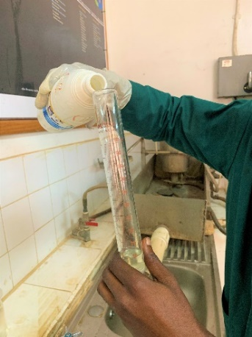

*Fig 3.1 :*Picture showing the measurement of 10ml of NaOCL

**Pie pan Extraction Method**

This method is sometimes also called the modified Baermann technique, or the Whitehead tray method.

Equipment required are:

• A domestic sieve

• A dish/tray/plate, slightly larger than the basket

• Extraction paper

• Permanent marker for labelling the sample

• Knife/scissors

Procedure for extraction of nematodes from soil samples using Pie pan extraction method

1. Remove roots from sample and place in a separate dish. Label.
2. Using a coarse sieve, remove stones and debris from soil and break up soil lumps.
3. In a plastic container (basin, bucket) thoroughly mix the soil sample. Remove a measure of soil (e.g. 100 ml).
4. Place extraction paper in the plastic sieve/basket (placed on a plastic plate) ensuring that the base of the sieve is fully covered by the tissue
5. Place the soil measured on the tissue in the sieve. It is important that the soil remains on the tissue paper as spillover results in dirty extractions.
6. Add water to the extraction plates . Take care to gently pour water into the plate (dish) and not onto the tissue paper or soil (between the edge of the sieve and the side of the tray).
7. Leave undisturbed for a set period (48 hours )
8. Nematodes from the soil or plant tissue will move through the tissue paper into the water below, resting on the tray/plate. After the extraction period, drain excess water from the sieve and the soil into the extraction.
9. Remove the sieve and dispose of plant tissue/soil. Pour the water from the plate into a labeled beaker (or cup), using a water bottle to rinse the plate.
10. Leave samples to settle .
11. For counting the nematodes in the extraction under microscope, reduce the volume of water by gently pouring off and then pick the extract onto slides for counting under microscope after adjusting the objective lens to a suitable magnification

Procedure for extraction of nematodes from root samples using Pie pan extraction method

1. Gently tap soil off the roots/tubers or rinse under a tap and then gently dab dry with tissue paper.
2. Chop the roots finely with a knife or scissors and place in a labeled dish .
3. Mix all chopped root material thoroughly. Remove and weigh a sub-sample (e.g. 5 g) of chopped root material using measuring scales
4. Place weighed sub-sample on the tissue paper in the labeled sieve/basket .
5. Follow the rest of the procedure for soil extraction above (steps g–k)

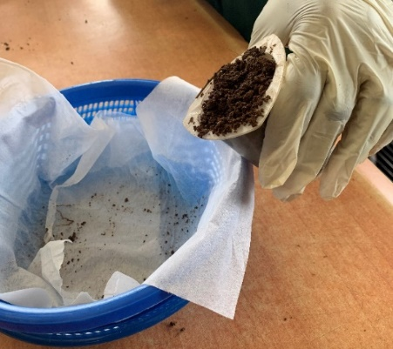

*Fig 3.2 :* Picture showing pouring of 100ml of soil into the extraction paper

****Nematode Control Methods****  
Methods of nematode control fall into three broad categories: Cultural practices, chemical control and biological control.

****Cultural Methods of Nematode Control****  
Rotating crops is a good way to control nematodes. You may have a crop that’s highly susceptible to nematodes, and then you rotate that field to other crops that are not susceptible. For example, if you have a field that you've been growing tomatoes in for 2-3 years and you rotate that to pasture grasses for 2-3 years, you will systematically and culturally control the nematodes.

The type of root-knot nematodes that damage tomatoes does not colonize the roots of grasses. When you transfer the field to grasses, you're basically creating an environment where the root-knot nematode no longer has a host. If you remove the host, the population will decrease in the field. This is the opposite of monocropping, where you grow the same crop over and over again, allowing the population of nematodes to become progressively more problematic year after year. Crop rotation is a cultural way of controlling nematodes, and it can work quite well. There are even cover crops which produce chemicals that are toxic to nematodes. However, if you have several types of nematodes in your soil, finding a crop rotation that will starve out all of them can be a bit tricky.

Mechanical methods, such as repeated tilling of fallow soil, may also be useful, but may be difficult to implement on a large scale.

****Chemical Control of Nematodes****  
Chemical controls include fumigants and nervous system toxins. Fumigants have to penetrate a large volume of soil to be effective, and some of them volatize quickly. Large amounts of chemicals are often used, leading to increased risk and expense. Methyl bromide, a broad-spectrum pesticide often used for nematode control, is being phased out under the Clean Air Act. This has led to a search for alternatives.

Nervous system toxins can also provide effective nematode control. Because they are not toxic to plants, these chemicals (carbamates and organophosphates) can be applied after plants are growing and nematode damage is visible. However, since human beings also have nervous systems, any chemical treatments that target the nematode nervous system are a potential danger to humans. These chemicals are extremely toxic to humans and other non-target organisms, but there are alternatives.

****Biochemical and Biological Nematode Control****  
Biochemical and biological controls can be used in conjunction with other controls or on their own. By naturally repelling nematodes and improving plant health, these methods may decrease dependence on chemical controls.

### CHAPTER FOUR

### IDENTIFICATION OF NEMATODES

There are various means of nematodes identification such as the morphological, anatomical and molecular analysis. In International Institute of Tropical Agriculture Nematology Unit, morphological features used to identify the nematodes are:

* The shape of the head e.g. offset etc.
* The shape of stylet e.g. long, short, thin and thick.
* The gland overlapping e.g. ventral or dorsal etc.
* The vulva position e.g. 50% of the actual length, 70% etc.
* The shape of the tail e.g. coniod, round etc

During the course of my training, different species of nematodes identified are as follow:

* *Pratylenchus spp*
* *Radopholus spp*
* *Scutellonema spp*
* *Hoplolaimus spp*
* *Helicotylenhus spp*
* *Meloidogyne spp*

**Morphological Features of *Pratylenchus Spp***

* Head shape: Offset and low
* Stylet: Short and thick
* Gland overlap: Ventral
* Vulva position: 70-75%

.

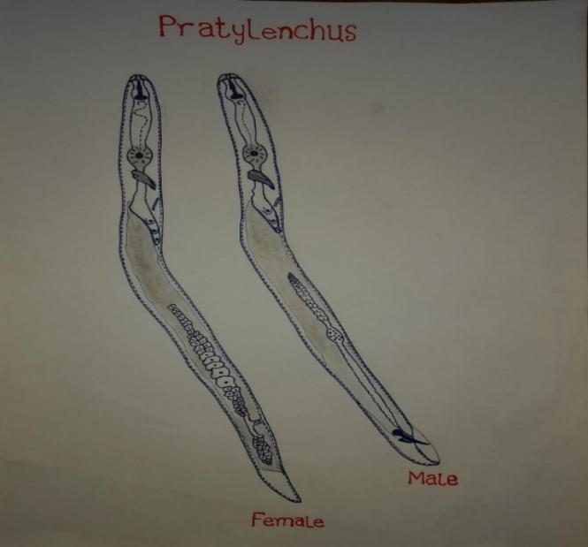

*Fig 4.1 :* Diagram showing *Pratylenchus spp*

**Morphological Features of *Scutellonema Spp***

* Head shape: offset
* Stylet: Long and thin
* Gland overlap: Dorsal
* Vulva position: 50%
* Tail shape: Rounded

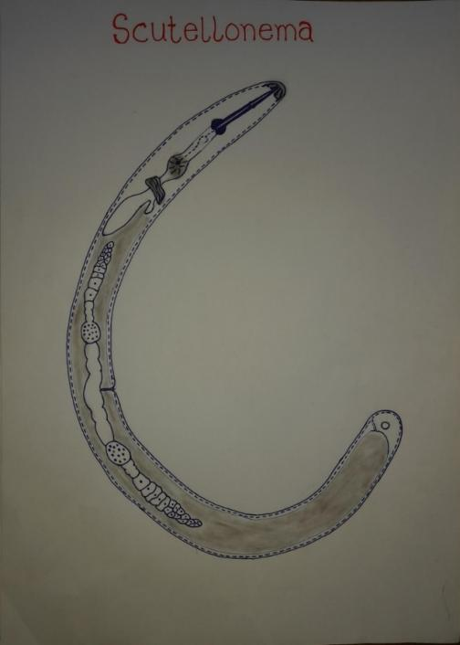*Fig 4.2:* Diagram showing *Scutellonema Spp*

Plate 23. Hand drawing of Radopholus.

**Morphological Features of *Hoplolaimus Spp***

* Head shape: Offset
* Stylet: Long and thin
* Gland overlap: Dorsal
* Vulva position: 50%
* Tail shape: Rounded

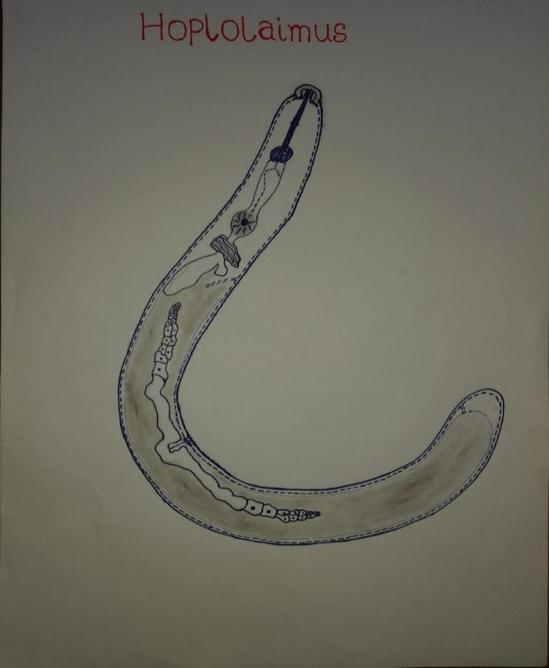

*Fig 4.3:* Diagram showing Hoplolaimus Spp

**Morphological Features of *Helicotylenchus Spp***

* Head shape: Offset
* Stylet : Long and thin
* Gland overlap : Ventral
* Vulva position: 70%
* Tail shape: Conoid

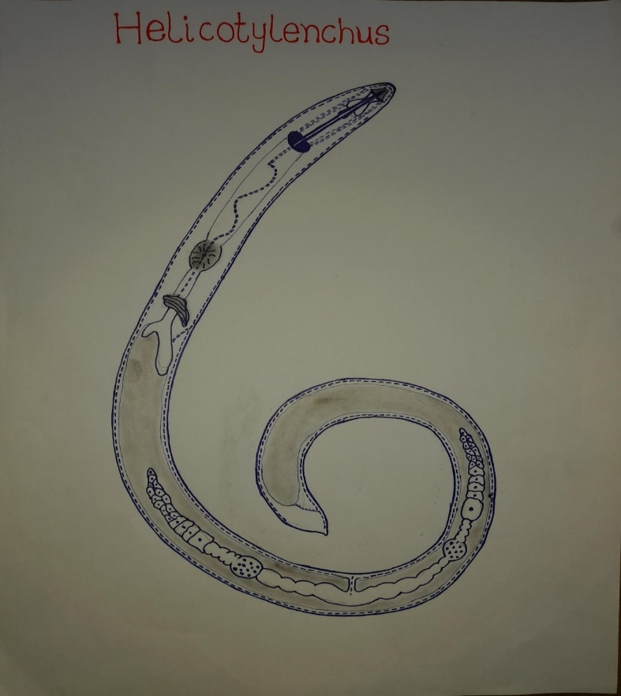

Fig 4.4: . Diagram showing Helicotylenchus Spp

**Morphological Features of *Radopholus Spp***

* Head shape: Offset (male), flat (female)
* Stylet: Short and thick
* Gland Overlap: Dorsal
* Vulva position: 50-60%

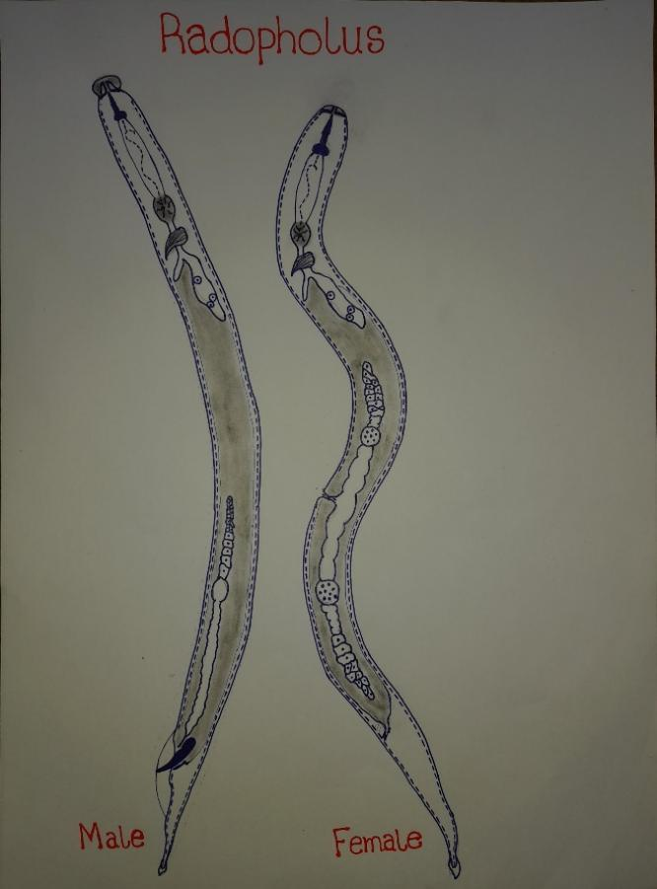

*Fig 4.5:* Diagram showing Radopholus Spp

*Radopholus spp* exhibits sexual dimorphism (males are different from females)

**CONCLUSION**

The student Industrial Work Experience Scheme (SIWES) program was a transformative journey, equipping me with a set of skills that go beyond the classroom and into the realm of real-world working experiences. This industrial training has not only enhanced my sense of responsibility but has also given me a profound understanding of practical applications in my field of study. It also allowed me to cultivate strong inter-personal relationships, which is essential for navigating the complexities of the adult world.

The experience I had at the Nematology Unit of the International Institute of Tropical Agriculture (IITA), Ibadan, has significantly shaped my knowledge about crop protection. I gained hands-on experience in culturing nematodes, observing their effects on plants, extracting nematodes from plant and soil samples, preserving and identifying different nematode species. This practical exposure has been invaluable in enhancing my understanding of managing nematode infestations and protecting crop yields.

As a Botany student, this training has enlightened, broadened my perspective and deepened my appreciation for my course of study. I was able to connect the theoretical knowledge I gained in the classroom with the practical realities of the field. Through this experience, I gained insights into how my academic pursuits relate to the broader world of agriculture.

Furthermore, this training instilled in me a strong sense of preparedness for the challenges that lie ahead in my academic and professional journey, gave me a glimpse of the real-world expectations and motivated me to continue honing my skills and knowledge as I strive to make a meaningful contribution to the field of Botany and the broader community.

**REFERENCES**

1. Brent S Sipes, 2014. Plant Parasitic Nematodes and their management. https://www.researchgate net/publication/29744605
2. Coyne, D.L., Adewuyi, O. and Mbiru, E. 2014. Protocol for in vitro culturing of lesion nematodes: Radopholus similis and Pratylenchus spp. On carrot discs. International Institute of Tropical Agriculture, Ibadan, Nigeria.
3. Coyne, D.L., Nicol, J, M. and Claudius – Cole, B. (2001). Practical Plant Nematology: A Field and Laboratory Guide. SP – IPM Secretariat, International Institute of Tropical Agriculture (IITA), Cotonou, Benin.
4. David J. Hunt, Jaun E. Palomares – Rius and Rosa H. Manzanilla. Lopez 2018. Identification, Morphology and Biology of Plant Parasitic Nematodes.
5. <https://www.iita.org/about-iita/>
6. https://www.soiltechcorp.com/blog/introduction-to-nematode-control/